Autodidactic Music Theory Learning Sheets (v0.3)

Big Thanks to all musicians around the world,
Tutors & Teachers and Players!

Sascha Hülsen "sh" - Berlin - 2022 [ cc:by sa ]

Scales of Harmony Ruleset (W hole – H alf – wH = 3H )

Frameable by an octave
Only H, W & wH
H cannot be Neighbors
W & wH cannot be Neighbors
wH cannot be Neighbours

Harmonic Scales – Harmonische Tonleitern

Major w w H w w w H
Melodic Minor w H w w w w H
Harmonic Minor w H w w H 3H H
Harmonic Major w w H w H 3H H
Diminished w H w H w H w
Inv Diminished H w H w H w H
Whole Tone w
Augmented 3H H 3H H 3H H
Eb Inverted H 3H H 3H H 3H

&

Minor w H w w H w w

Prime, gleicher Ton | 1 | 0 | ein Ton | The Tone
Kleine Sekunde, Halbton | ♭2 | 1 | sehr dissonant | Very dissonant
Grosse Sekunde, Ganzton | 2 | 2 | eher dissonant | Not so very dissonant
Kleine Terz | ♭3 | 3 | melancholisch | melancholic
Grosse Terz | 3 | 4 | feierlich | solemnly
Quart(e) | 4 | 5 | Rein - scharf | Pure and sharp
Übermässige Quart, verminderte Quint - Tritonus | ♯4 oder ♭5 | 6 | Spannung | exiting
Quint(e) | 5 | 7 | Rein - scharf | Sharp and pure
Erhöhte Quint, kleine Sexte | ♯5 oder ♭6 | 8 | Terzi air | Terz i airy
Sexte | 6 | 9 | Terzi air | Terz i airy
Kleine Sept(ime) | ♭7 | 10 | eher dissonant | More dissonant
Grosse Sept(ime) | 7 | 11 | dissonant | dissonant
Oktave | 8 | 12 | rein, klar | Pure & clear

Sounds like

Verminderte None | ♭9 | 13 | ♭2
None | 9 | 14 | 2
Erhöhte None | ♯9 | 15 | ♭3
Dezime | 10 | 16 | 3
Undezime | 11 | 17 | 4
Erhöhte Undezime | ♯11 | 18 | ♯4 oder ♭5
Duodezime | 12 | 19 | 5
Verminderte Tredezime | ♭13 | 20 | ♯5 oder ♭6
Tredezime | 13 | 21 | 6

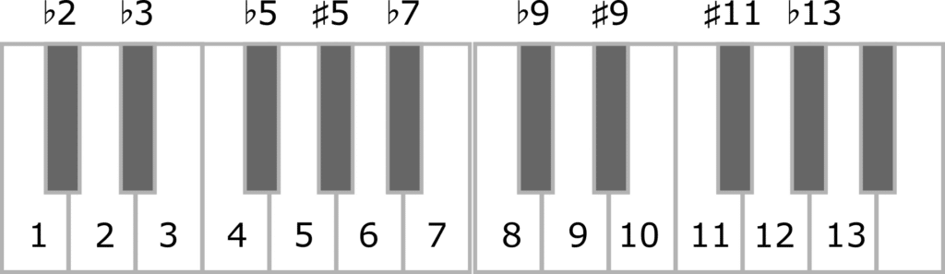

 | ♭ | Stammton / ♮ | ♯ | 
Ceses | Ces | C | Cis | Cisis
Deses | Des | D | Dis | Disis
Eses | Es | E | Eis (gesprochen: E-is) | Eisis
Feses | Fes | F | Fis | Fisis
Geses | Ges | G | Gis | Gisis
Asas oder Ases | As | A | Ais (gesprochen: A-is) | Aisis
Heses | B | H | His | Hisis

His  C  Deses | Hisis  Cis  Des | Cisis  D  Eses | Dis  Es  Feses | Disis  E  Fes | Eis  F  Geses | Eisis  Fis  Ges | Fisis  G  Asas | Gis  —  As | Gisis  A  Heses | Ais  B  Ceses | Aisis  H  Ces

